PLAN DE MEJORAMIENTO
Asignatura: Inglés
Grado tercero
Docente: Maria Alejandra Noreña Aristizabal
Nombre del estudiante: _________________________________________________________
1. For each of these clocks, write down the correct time in words:
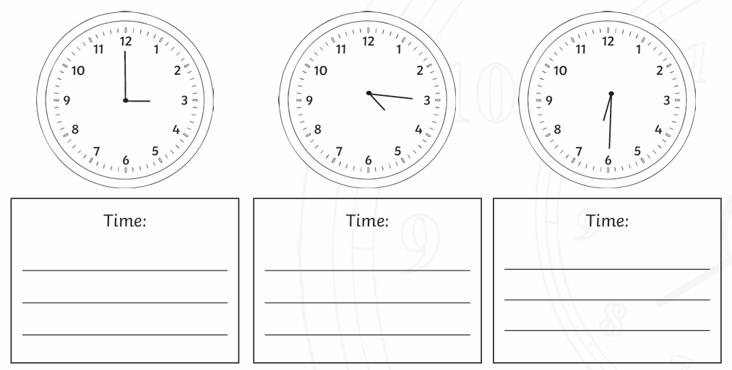
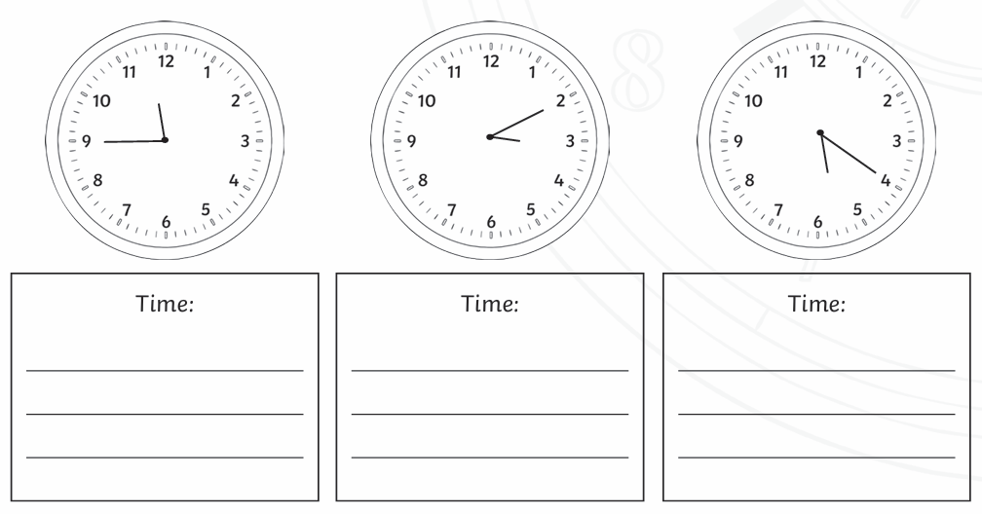
2. Count and write the number with their proper name:
EXAMPLE:
 Number: Thirty three (33)
 Number:  Number:
 Number:

3. Complete the following sentences with the daily routine and time shown in the picture:
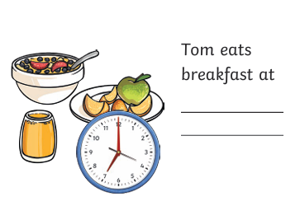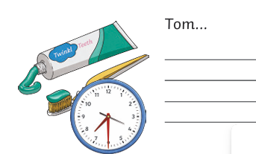
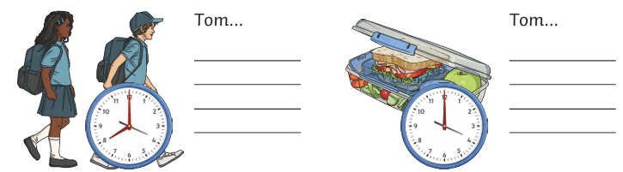
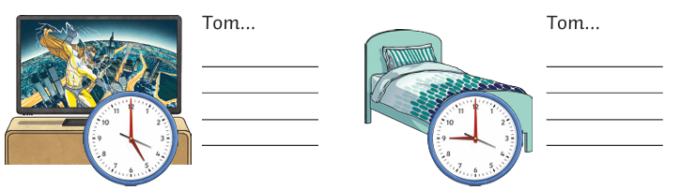

4. Describe what your family members are wearing (Minimum 4 people), Example: My mom is wearing…
__________________________________________________________________________________
__________________________________________________________________________________
__________________________________________________________________________________
_________________________________________________________________________________
_________________________________________________________________________________
5. Read and answer the following questions:
a. What time do you brush your hair?___________________________________________________
b. What time do you wake up?________________________________________________________
c. What time do you watch your favorite show?__________________________________________
d. What time do you brush your teeth? _________________________________________________
e. What time do you go to sleep? _____________________________________________________

