TALLER DE PLAN DE MEJORAMIENTO
Asignatura: Inglés
Grado cuarto
Docente: Maria Alejandra Noreña Aristizabal
Nombre del estudiante : _________________________________________________________
- Describe what a person should wear on the next seasons:
- Summer.
- Fall.
- Winter.
- Spring.
- Complete the next sentences, use the image to identify the weather.
- The weather today is _____________, so we can go to the beach. 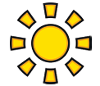
- The weather today is ____________, we should stay at home. 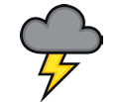
- The weather today is ____________, she should drive slow. 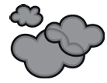
- The weather today is ____________, my family should stay at home. 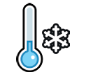
- The weather today is ____________, we should make a snowman. 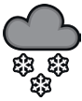
- Complete the next sentences using “SHOULD AND SHOULD NOT”.
- It is foggy outside, Kevin __________ drive slowly.
- You __________ brush your teeth everyday.
- I like this movie! You __________ watch it!
- It is very sunny today. We _________ go out without sunblock.
- You ________ read every day.
- It is hot at the beach, Alejo ____________ put on more protection.
- In winter, you ____________ wear a coat to keep warm.
- Read each sentence carefully and choose the correct form of the verb "DO" or "DOES" to fill in the blanks.
- Maria __________ not make her homework every evening.
- The cat _________ not like the water.
- ________ lions like to eat vegetables?
- ________ snakes like to sleep more than 3 hours?
- ________ tiger like to hunt?
- ________ he only eat leaves and pineapples?
- The bear ________ not like to attack other people.

