PLAN DE MEJORAMIENTO PERIODO 1
GRADO: 5°
ASIGNATURA: inglés
DOCENTE: Mayra Yepes
LOGROS:
- Evalúa los conocimientos previos de los estudiantes sobre los temas trabajados el año anterior, con el propósito de identificar su nivel de dominio y asegurar que cuentan con las bases necesarias para abordar los contenidos del nuevo año escolar.
- Comprende información general y específica en un texto narrativo corto sobre temas conocidos y de interés.
- Intercambia información sobre hábitos, gustos y preferencias acerca de temas conocidos, siguiendo modelos provistos por el profesor.

- Read and draw the farm animals.
It gives us wool. It gives us milk.

It gives us eggs. It wakes us up in the morning.

- Unscramble the sentences:.
- is / elephant / than / a / bigger / cat
________________________________________________________________
- cheetah / than / a / faster / is / a / lion
________________________________________________________________
- smarter / dolphin / a / a / is / than / shark
________________________________________________________________
- a / turtle / slower / a / than / is / rabbit
________________________________________________________________
- Make sentences using 'could' and 'couldn't'.

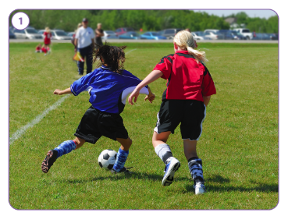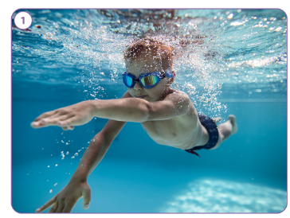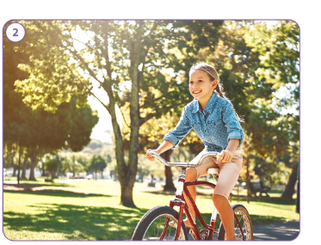
________________________ _______________________ _______________________
________________________ _______________________ _______________________
________________________ _______________________ _______________________
________________________ _______________________ _______________________
________________________ _______________________ _______________________

- Write about your personal information:
________________________________________________________________________________________________________________________________________________________________________________________________________________________________________________________________________________________________________________________________________________________________________________________________________________________________________________________________________________________________________________________________________________________________________________________________________________________________________________________________
- Read and draw.
- You play this game with a lot of small b. You can play this sport on the beach.
balls. You need a net, a ball, and two teams.

- Many players of this sport are very tall. d. You need a bat, a ball, and a glove to
You need a basket and a ball to play. play this sport.

- Write about your favorite sport and your favorite sport person:
________________________________________________________________________________________________________________________________________________________________________________________________________________________________________________________________________________________________________________________________________________________________________________________________________________________________________________________________________________________________________________________________________________________________________________________________________________________________________________________________

- Write sentences.
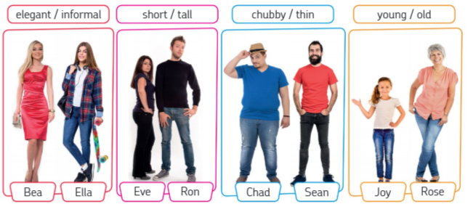
a.________________________________________________________________________
b. ________________________________________________________________________
c. ________________________________________________________________________
d. ________________________________________________________________________
e. ________________________________________________________________________

