**TALLER- PLAN DE MEJORAMIENTO SEGUNDO PERIODO**

|  |  |
| --- | --- |
| **TEACHER:** Juan Andrés Arango Velásquez. | **GRADE: 11º** |
| **DATE:** | **SUBJECT:** English |

**LOGROS:**

* Expresa de manera oral y escrita su posición acerca de un tema conocido teniendo en cuenta a quién está dirigido el texto.
* Redacta textos argumentativos con una estructura clara y sencilla sobre temas académicos.

1. **Look at the pictures. Use the words below to complete the second conditional sentences.**

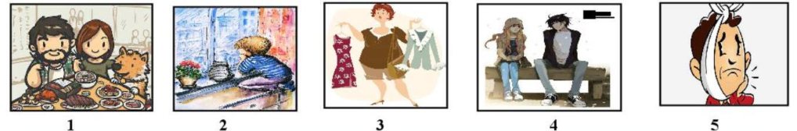

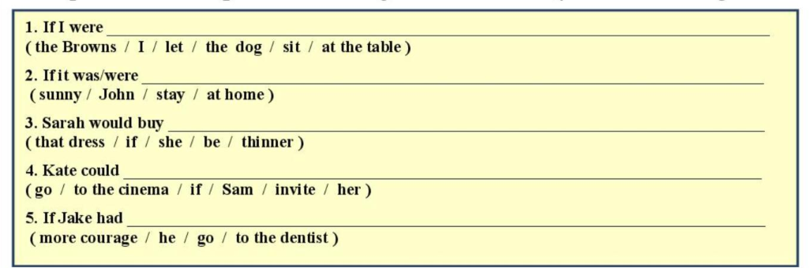

1. **Complete the second conditional questions with the verbs in brackets.**

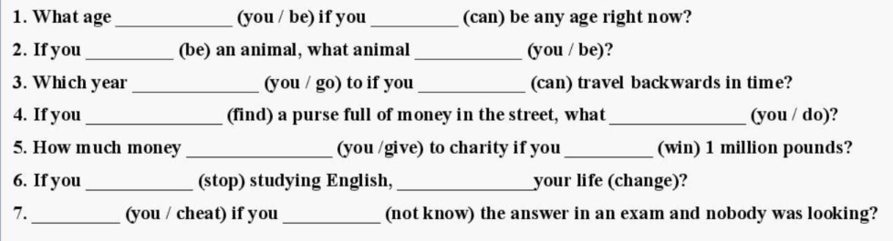

1. **According to the comic, write a paragraph explaining what is happening using Present perfect.**



________________________________________________________________________________________________________________________________________________________________________________________________________________________________________________________________________________________________________

1. **Write ideas using first conditional. ¿Qué podrías hacer sí gobernaras el mundo?**

If I rule the world, I would….

________________________________________________________________________________________________________________________________________________________________________________________________________________________________________________________________________________________________________ ________________________________________________________________________________________________________________________________________________________________________________________________________________________________________________________________________________________________________ _______________________________________________________________________________________________________________________________________________________________________________________________________________________________________________________________________________________________________ __________________________________________________________________________________________________________________________________________________________________________________________________________________________________________________________________