TALLER - PLAN DE MEJORAMIENTO PERIODO 2
Asignatura: Inglés
Grado tercero
Docente: Maria Alejandra Noreña Aristizabal
LOGROS:
1.Responde, de manera oral o escrita, preguntas sencillas sobre textos descriptivos cortos y alusivos a temas conocidos y de clase.
2. Intercambia ideas y opiniones sencillas con compañeros y profesores, siguiendo modelos o a través de imágenes.
Nombre del estudiante: _________________________________________________________
- Look at the image and write. Use the verbs that we write and practice in class.
a. | b.  | c.  | d. | e. | f.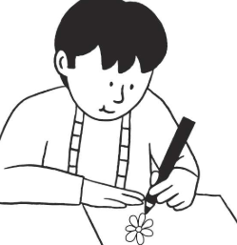
a. | b. | c. | d. | e. | f.

- Unscramble the next senteces.
- Playing / are / They / tennis
- Is / running / She / at school
- Marcos and I / reading / a book / are
- am / feeding / the cats / I
- riding / He / a bicycle / is
- Make 6 sentences with -ing of what you do in a normal day.
- Look at the image and then complete the sentences with “THEIR” or “OUR”
 -We are sister’s. _________ hair is long
- They are brother’s. _______ is blue.
-We are friends. __________ houses are near.
- Select 3 places of your house, draw it and make 3 sentences with -ing.
EXAMPLE:
1. My mom is cooking dinner.
2. I am preparing the table to eat with my family.
3. My dad is helping my mom.
6. Name the next places.
