TALLER - PLAN DE MEJORAMIENTO PERIODO 2
GRADO: 5°
ASIGNATURA: Inglés
DOCENTE: Mayra Yepes
LOGROS:
- Explica causas y consecuencias de una situación a través de oraciones simples de manera oral y escrita siguiendo un modelo establecido.
- Respeta las características y diferencias culturales de las personas.

- Write. Use the clues and was, wasn’t, were, or weren’t.
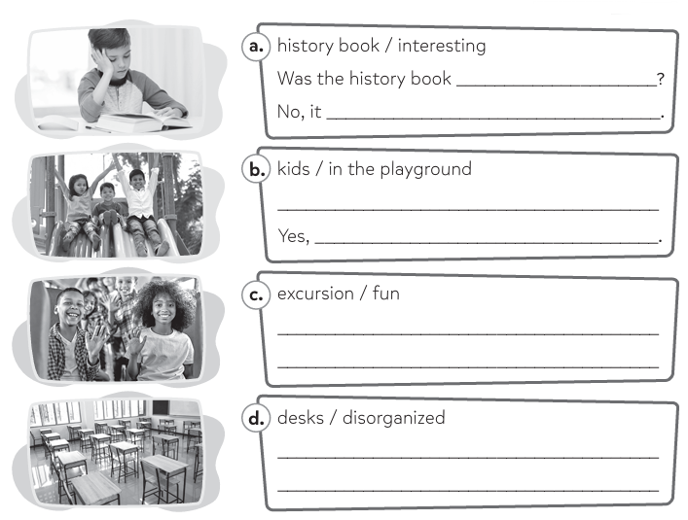

- Complete with was or were.
Hi Megan,
People at school are so different after the end-of-year holiday!
Our math teacher’s beard __________ short, but now it’s long!
Andrew’s hair is short, and it __________ so long!
The Wilson brothers ___________ short. Now they play basketball and are quite tall.
And do you remember the Hoffman sisters? Their hair _________ wavy, and now it’s completely straight.
And you and me? I remember we________ short, but I’m different now, I’m taller! Are you taller now? I really liked your hair, it __________ long and curly. Send me a photo of how you look now!
Write soon,
Cooper
- Look and complete with was, wasn’t, were, or weren’t.
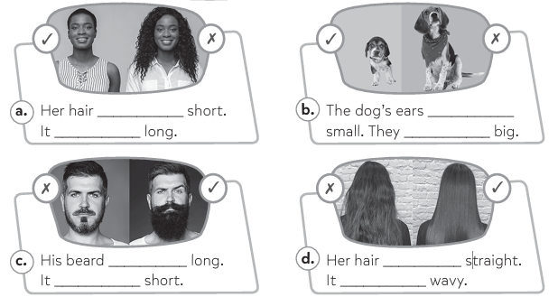

- Write the places:
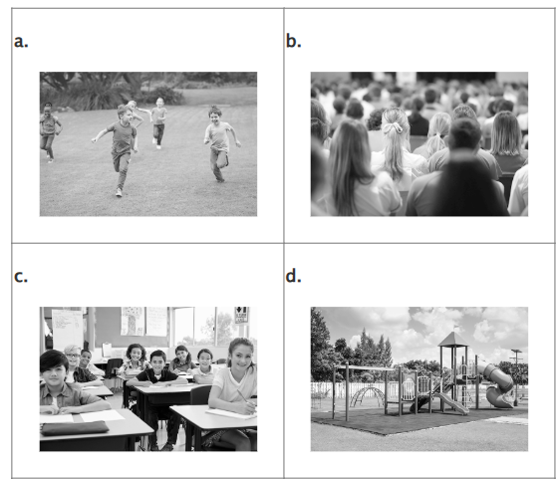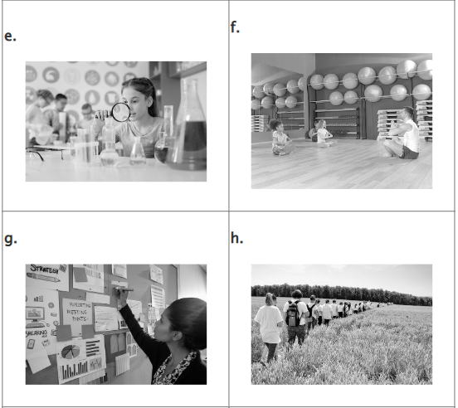
- Describe the people:

  
  
  
  
  

