TALLER - PLAN DE MEJORAMIENTO SEGUNDO PERIODO
TEACHER: Juan Andrés Arango Velásquez y Nicolás Maya Hernández | GRADE: 9º
DATE: | SUBJECT: English

LOGROS:
- Represento de manera creativa, puntos de vista, pensamiento o ideologías, esto con el fin de dar a entender a un público un criterio según la situación.
- Participo activamente en interacciones con mis compañeros y profesor para tomar decisiones sobre temas que conozco, usando lenguaje formal o informal según el contexto.
1. Une los verbos en infinitivo a su verbo en pasado simple.
- tick – pressed
- scratch – looked
- crash – answered
- boil – crashed
- answer – ticked
- clean – scratched
- look – boiled
- push – cleaned
- press – pushed
- knock – knocked

Fill in the past tense:
- jump – __________
- add – __________
- walk – __________
- open – __________
- talk – __________
- laugh – __________
- call – __________
- chew – __________
- comb – __________
- paint – __________
2) Ordena las palabras para formar oraciones con pronombres indefinidos
- anywhere / didn’t / yesterday / find / I / interesting
- to / somewhere / wants / travel / my / this / cousin / summer
- the / something / told / about / strange / he / party / me
- nobody / in / wants / the / to / help / kitchen
- will / everything / be / for / ready / tomorrow / the / meeting
3.) Usando el Past progressive narra algunos acontecimientos de tu vida.

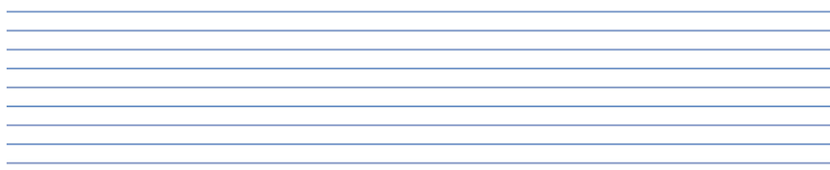

5). Escribe una pequeña historia graciosa de algún acontecimiento de tu vida usando el Past Simple.
6) Ordena las palabras para formar oraciones en voz pasiva
- the / is / homework / by / done / every day / students
- cleaned / the / is / kitchen / every morning
- the / painted / was / house / last year / by / workers
- by / is / eaten / lunch / us / at / noon
- are / the / letters / sent / every week / by / secretary

